**WIRING HANDOUT #2**

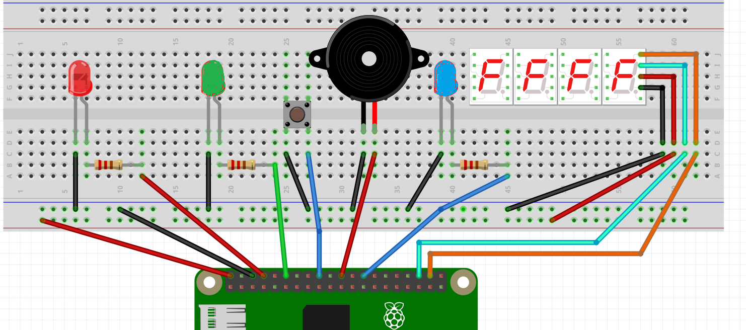

**PEDESTRIAN CROSSING WITH ANTI SPAM AND COUNTER**

**ANTI SPAM LIGHT**

**TM1637 7 SEGMENT DISPLAY**

**ANTI SPAM PIN 7**

**CLK PIN 20**

**DIO PIN 16**

**CLK**

**DIO**

**VCC**

**GND**

**PIN 25**

**PIN 24**

**PIN 18**

**PIN 14**

**GROUND**